**\*\* TEST PLAN \*\***

**Git Repo: https://github.com/jemin6/CIS322**

**By. *Je Min Son***

**Test plan covers:**

1) Create new users

2) Login to the system

3) Add facilities

4) Add Assets

5) Complete the asset transit process

6) Dispose of an asset

7) Run each or the reports

** Test should be followed step by step.

** If the application returns the expected output, consider as succeed. Otherwise, if it fails please provide the feedback.

***HOW TO START***

1) Start up new database.

ex) pg_ctl –D /home/osnapdev/data -l logfile start

2) Create new database.

ex) createdb lost

3) Run preflight script

ex) bash preflight.sh lost

4) Apachectl start or python app.py

5) Go to http://127.0.0.1:8080/

***1) Create new user***

First thing to do is create new users. When you go to http://127.0.0.1:8080/, you will see CREATE user button on the top left. (Screenshots provided)

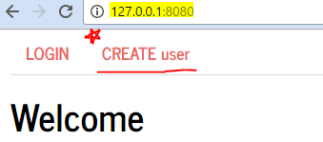

Figure First page you see.

Click CREATE user, or just directly type (http://127.0.0.1:8080/create_user).

Here, you can create new users. Enter the username (Length should be less than 16 characters) you want, and also the password (Less than 16 characters). Additionally, select the role which you want. There are only two choices provided (Logistic or Facility Officer).

If successfully created, then pops up the message saying succeed message, else failed message.

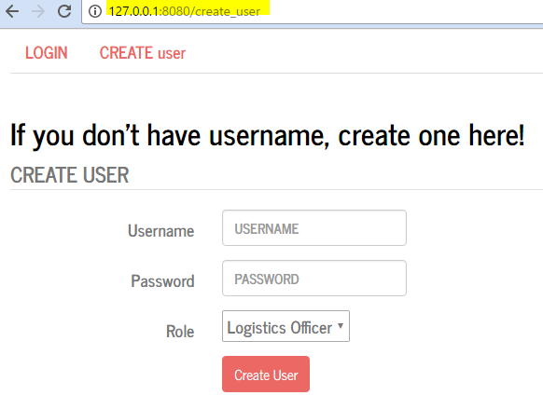

Figure . Create users screen

***2) Login to the system***

After creating two users (one is Logistic Officer, and the other one is Facility Officer), next test it to check if we can actually use that username and password to login.

You can click on to LOGIN button on the menu bar, or go to http://127.0.0.1:8080/login.

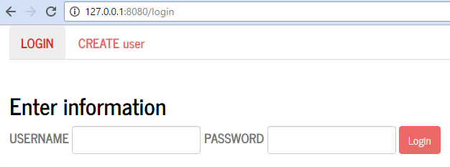

Figure . Login Screen

Only need to type the username and password. Does not need to select if it’s Logistic or Facility Officer. If login in is succeed, it will go to show up the dashboard as shown below.

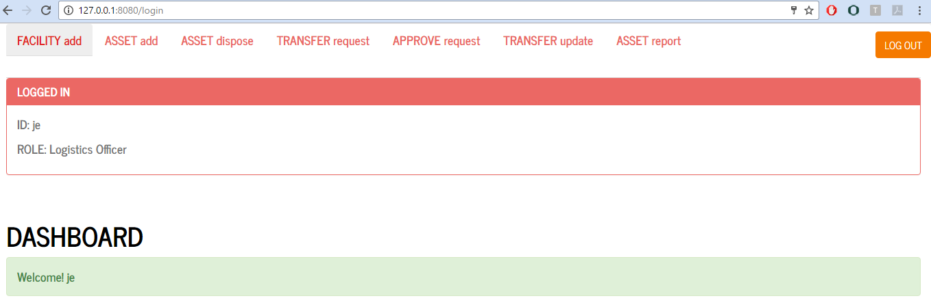

Figure . After successfully logged in. Shows your ID and ROLE on each pages.

Else, if username or the password is wrong, it will give error messages. (Figure 5)

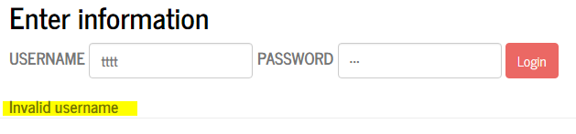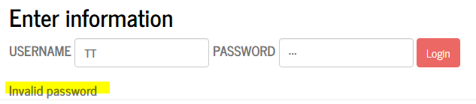

Figure . Invalid username & Invalid password

***3) Add facilities***

This step is adding new facilities into the database. When you have successfully logged in, you will see the FACILITY add button on the menu bar. Click it, then you will see page like figure 6.

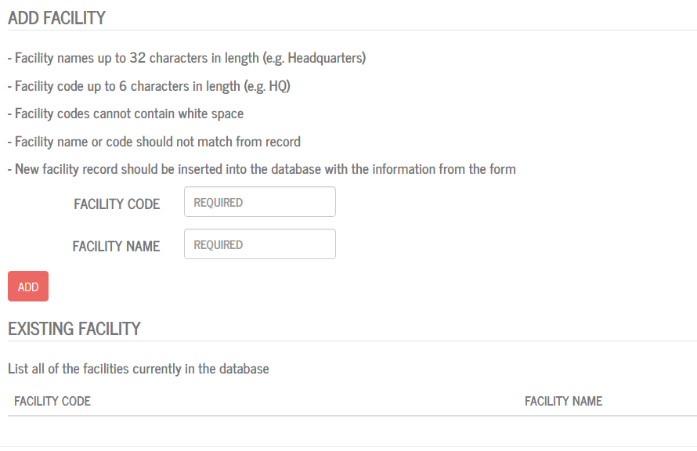

Figure . add facility here

There are also instructions on the page, and under that you will see the place where you can insert the facility code and name.

Facility code is up to 6 characters in length while name can be long as you want. Careful about the facility code which is case-sensitive. After typing in which code and name you want, press ADD button to add it into the database. If it is successfully added, it will pop up the message saying request succeed. Then, the code and name will be displayed under at the table (Figure 7).

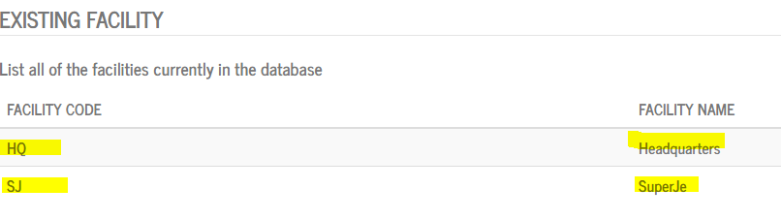

Figure .Showing the existing facility table

***4) Add assets***

This step is adding assets. Adding facility should be done before this step. So, it you haven’t added at least two facilities, go back and add it.

You can click on to ASSET add on the menu bar or go to http://127.0.0.1:8080/add_asset. Then you will see the screen shown below (figure 8).

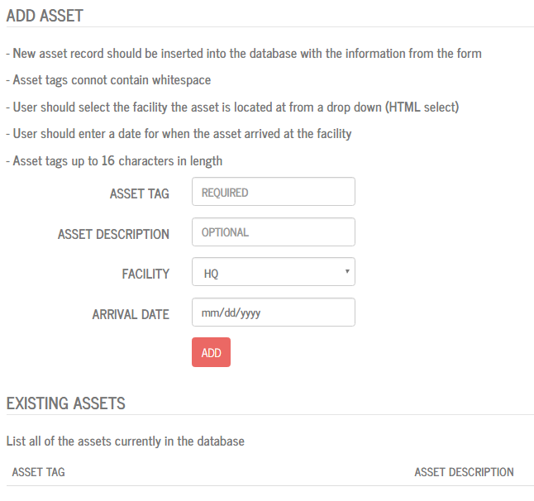

Figure . add asset page

As shown in the screenshot, you can type in asset tag (no longer than 16 characters) which is required. However, asset description is optional, so you don’t have to always type it in. Since you already added facilities before this step, you can choose them from the drop-down menu. Additionally, arrival data is required. It had the date format MM/DD/YYYY. Detailed descriptions are shown on the page.

When your inputs are valid and click ADD, it will pop up message saying succeed. Else, if the asset tag is already added, it will show warning message. ** ***If you don’t insert anything, it will also not work****.* However, after successfully added, it will show under at the existing assets table (figure 9).

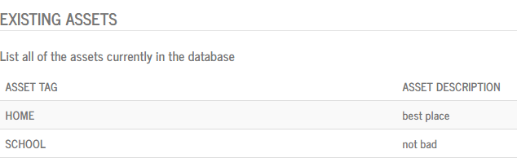

Figure . Existing asset shown after ADD

***5) Complete the asset transit process***

***6) Dispose of asset***

This step is disposing the asset. This page is only allowed for Logistic Officer, so if you logged in as Facility Officer, log out and please login as Logistic Officer. However, if you try to go to this page as Facility Officer users, then it will redirect to page showing error (Figure 10).

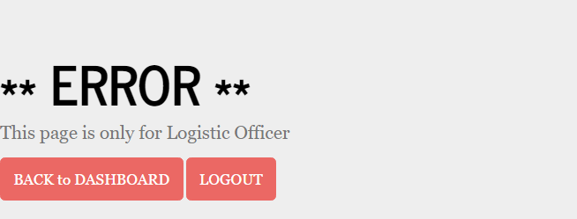

Figure . Error message

When you are logged in as Logistic Officer, you will see screen like below (Figure 11).

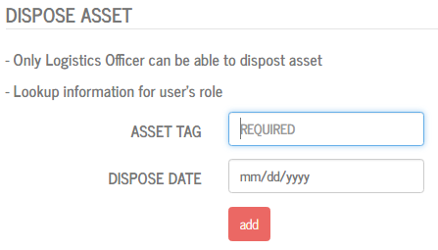

Figure . Dispose asset screen

Type in the asset tag and select date from the drop-down with the asset you want to dispose. If it is successfully disposed, it will pop up succeed message. However, if it fails it will give warning pop up.

To check, go to the database and check the asset_at table.

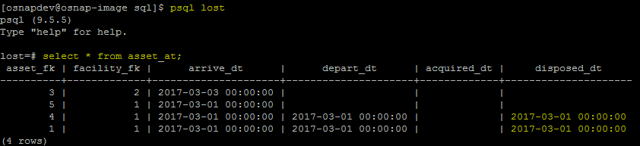

Figure . check if the change has been made

***7) Run each of the reports***

This step is to check the reports, we have two report pages. One is asset report page (http://127.0.0.1:8080/asset_report) and the other one is transfer report page. Each of them can be clicked on the menu bar on the top of the page.

On the asset report page, select the facility name from the drop-down menu and put in the date you want to display. After, click DISPLAY button to see what is stored inside the chosen facility and date.

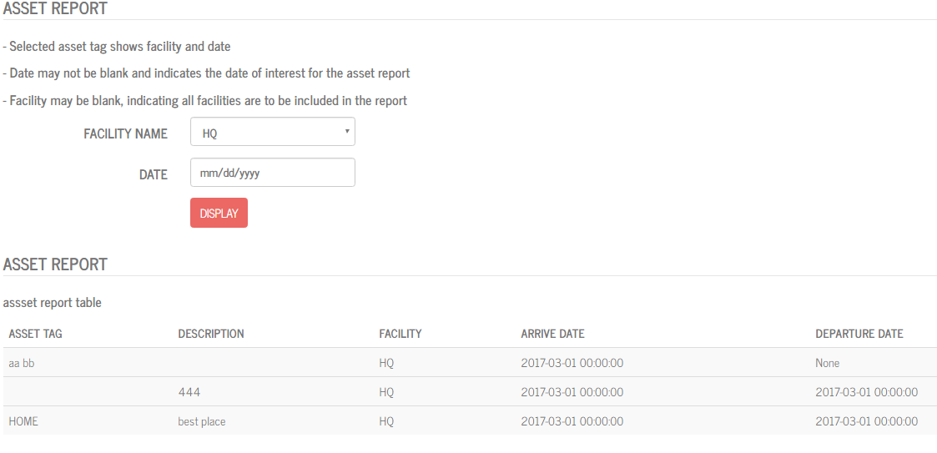

Figure . Asset report page

On the transfer report page, it similar to the asset report page. The difference is